Question 22

JD521 Summitive

6955 Laikin Barnard

Contents

Question: 2

CODE: 3

Customer 3

Finance_Period 5

Customer_Finance 6

Solution: 8

Result: 10

# Question:

Create a class named Customer that will determine the monthly repayment amount due by a customer for a product bought on credit. The class has five fields: customer name, contact number, product price, number of months and the monthly repayment amount. Write get and set methods for each field, except for the monthly repayment amount field. The set methods must prompt the user to enter the values for the following fields: customer name, contact number, product price and number of months. This class also needs a method to calculate the monthly repayment amount (product price divided by the number of months).

Add a subclass named Finance_Period that will determine if a customer will pay interest or not. If the number of months to pay for the product is greater than three, the customer will pay 25% interest, else no interest applies. The maximum number of months to pay for the product is 12. Override the calculate_repayment () method by determining if the customer will pay interest or not and calculate the monthly repayment amount.

Create a class called Customer_Finance that contains the logic to test the two classes. Prompt the user for data for the first object where no interest applies and display the results; then prompt the user for data where interest is applicable and display the results.

# CODE:

## Customer

/* Laikin Barnard 6955*/

package Question22;

import javax.swing.JOptionPane;

public class Customer {

//variables for storing customer data

String customerName;

int contactNumber;

double productPrice;

double numberOfMonths;

double monthlyRepaymentAmount;

Object monthlyRepaymentAmountc;

//getter and setter methods

public String getCustomerName() {

return customerName;

}

public void setCustomerName() {

this.customerName = JOptionPane.showInputDialog("please enter the customer name: ");

}

public int getContactNumber() {

return contactNumber;

}

public void setContactNumber() {

this.contactNumber = Integer.parseInt(JOptionPane.showInputDialog("please enter the customer contact number: "));

}

public double getProductPrice() {

return productPrice;

}

public void setProductPrice() {

this.productPrice = Double.parseDouble(JOptionPane.showInputDialog("please enter the price of the product: "));

}

public double getNumberOfMonths() {

return numberOfMonths;

}

public void setNumberOfMonths() {

this.numberOfMonths = Double.parseDouble(JOptionPane.showInputDialog("please enter the number of repayment months: "));

}

public void calculate_repayment(){

System.out.print("hello");

monthlyRepaymentAmount=productPrice/numberOfMonths;

}

}

## Finance_Period

/* Laikin Barnard 6955 */

package Question22;

public class Finance_Period extends Customer {

//if months<=3 no interest or else interest

@Override

public void calculate_repayment() {

// TODO Auto-generated method stub

if(numberOfMonths<=3)

{

monthlyRepaymentAmount=productPrice/numberOfMonths;

}

else

{

double interest= (25.0/100.0) * productPrice;

double amount=productPrice + interest;

monthlyRepaymentAmount=amount/numberOfMonths;

}

}

}

## Customer_Finance

/* Laikin Barnard 6955*/

package Question22;

import javax.swing.JOptionPane;

public class Customer_Finance {

public static void main(String[] args) {

//two objects . first with interest and second with no interest

Finance_Period a=new Finance_Period();

a.setCustomerName();

a.setContactNumber();

a.setProductPrice();

a.setNumberOfMonths();

a.calculate_repayment();

display_info(a);

Finance_Period b=new Finance_Period();

b.setCustomerName();

b.setContactNumber();

b.setProductPrice();

b.setNumberOfMonths();

b.calculate_repayment();

display_info(b);

}

//displaying message box

public static void display_info(Customer c){

String info=String.format("Customer Name: %s \n Customer Contact: 0%d \n Product Amount: R%.2f \n Repayment Months: %.0f\n Monthly Repayment R%.2f\n Total Due: R%.2f\n",c.customerName,c.contactNumber,c.productPrice,c.numberOfMonths,c.monthlyRepaymentAmount,c.monthlyRepaymentAmount*c.numberOfMonths);

JOptionPane.showMessageDialog(null, info);

}

}

# Solution:

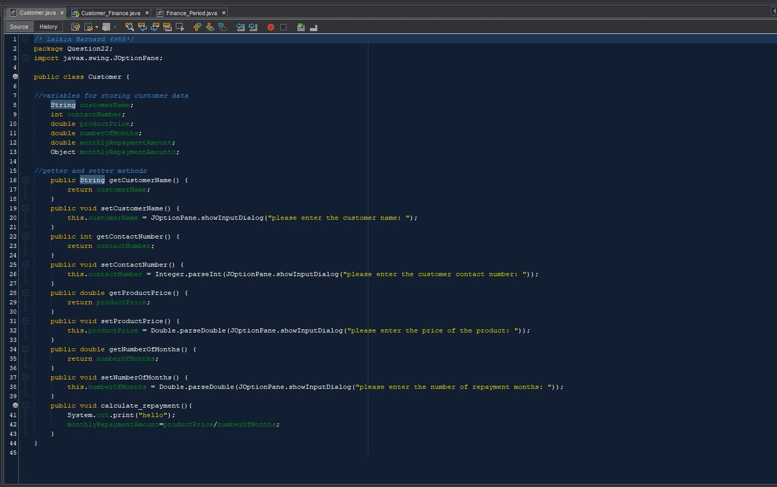

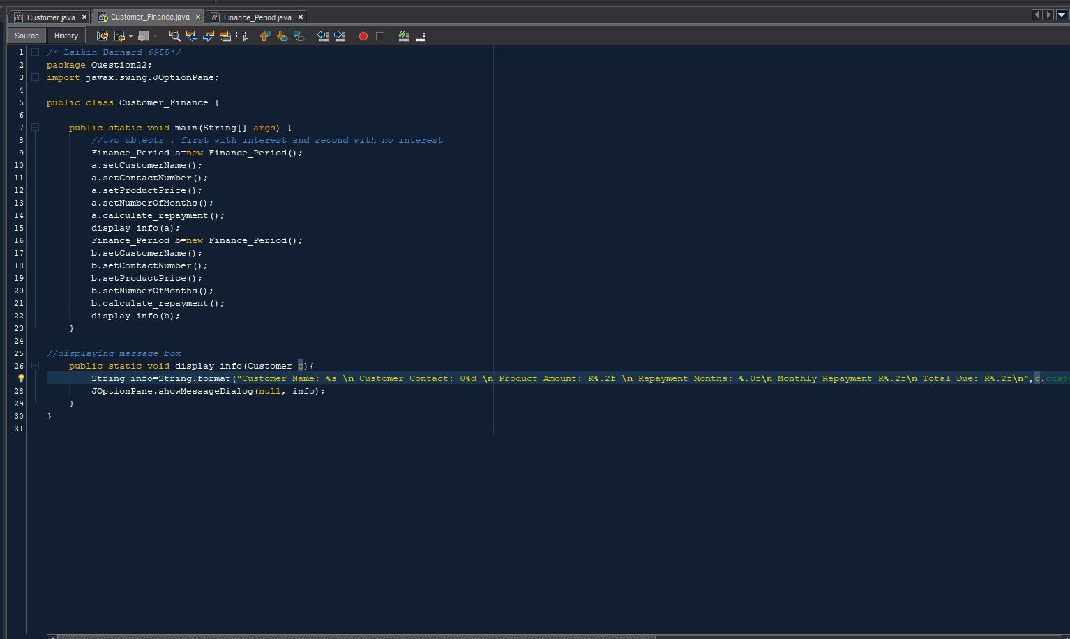

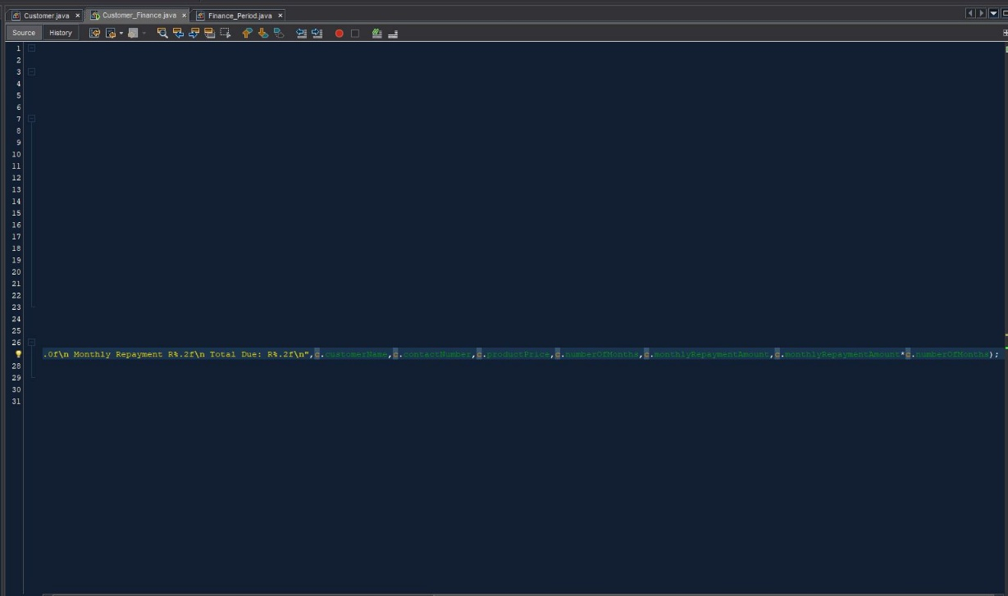

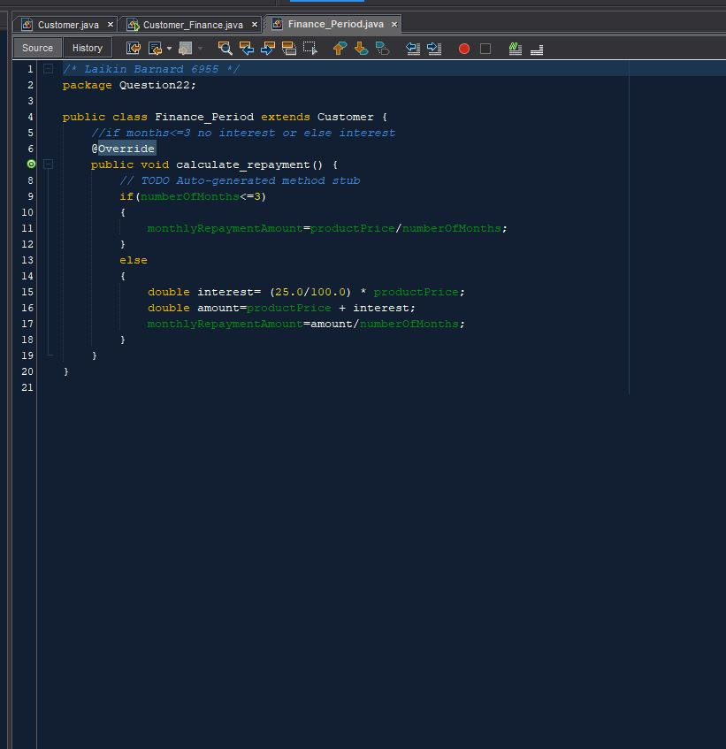

# Result:

